Phase Change Lab

Objective:
Create a temperature versus time graph of water as it goes through each of its phase changes.

Materials
Buchner flask
Ice tray
Blender
Vernier Surface Temperature Sensor
Hot pad with magnetic stirring capabilities
Magnetic stirrer
Ring stand
Ring stand flask clamp
Silicone heat resistant sealant
Rubber flask stopper with hole drilled in center and side slit
Balloon
Rubber Band
Rubber gas tubing
Glass T shaped splitter
Ice
Safety glasses
Rubber tongs

Pre-Lab Procedure

Measurements
- Measure the mass of the flask, rubber stopper, surface temperature sensor and stirrer.

Rubber Tubing
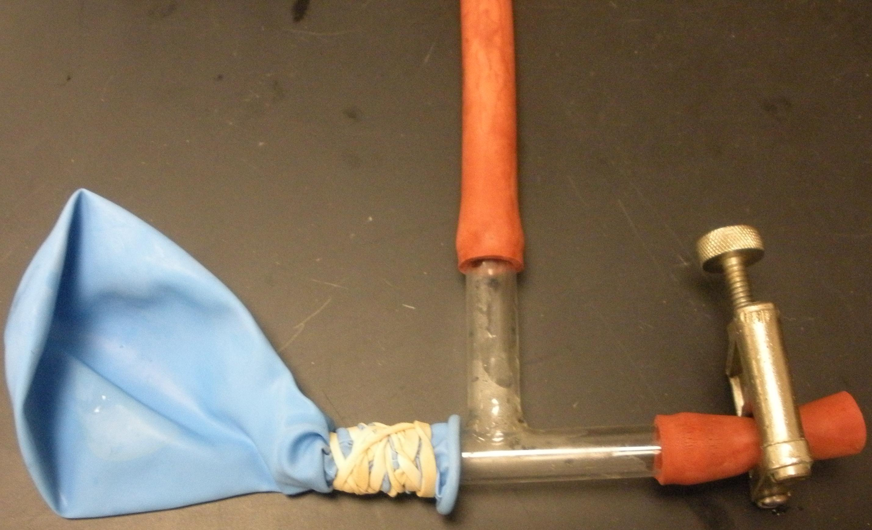 | - Cut a section of gas rubber tubing that will reach from the Buchner flask arm to the table.  - Connect the tubing to gas T-shaped tubing split.  - Connect a small section of rubber gas tubing to one open side of the T and place a valve on over the tubing.  - Rubber band a balloon to the other side of the T.

Rubber Stopper
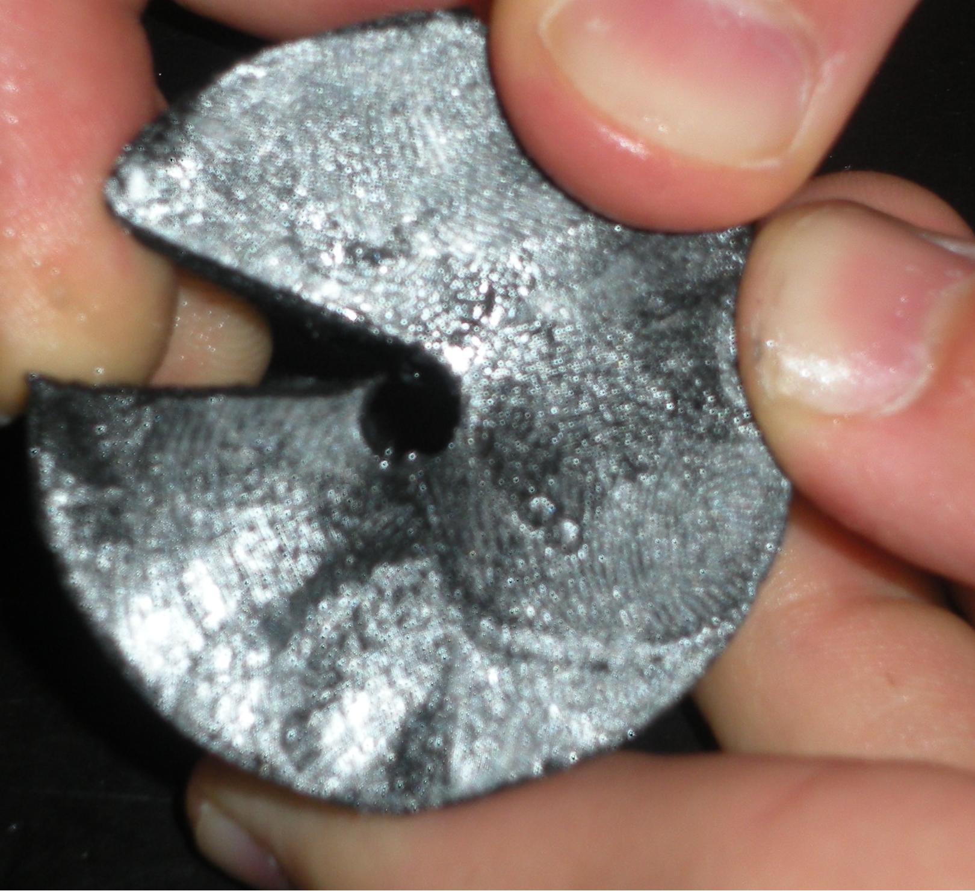 | - Drill hole in top center of rubber stopper through bottom center.  - Cut the stopper from the side of the hole just drilled (this allows the thermistor wire to be inserted through the center of the stopper).

Ice
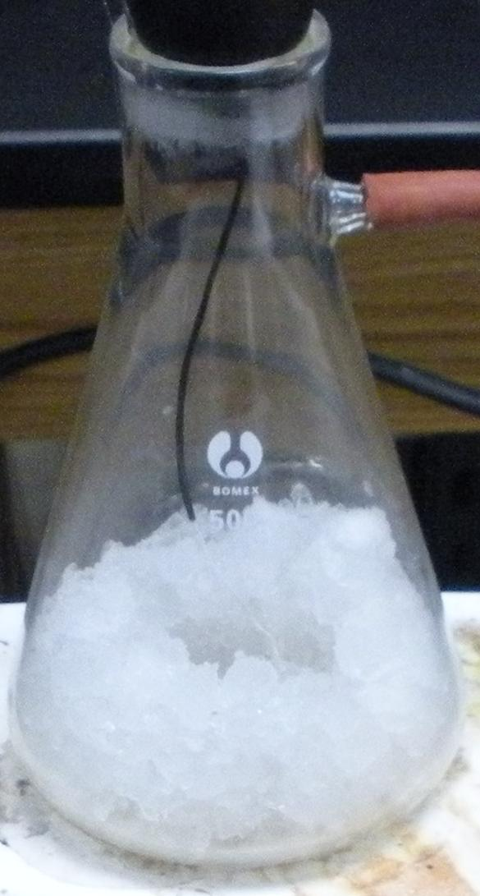 | 1. Chip enough ice to fill approximately one fifth of the flask.  2. Place chipped ice in a torus (donut-like manner) in the flask, leaving a pocket of open space in the center to place the stirrer.  3. Place stirrer in opening.

Thermistor
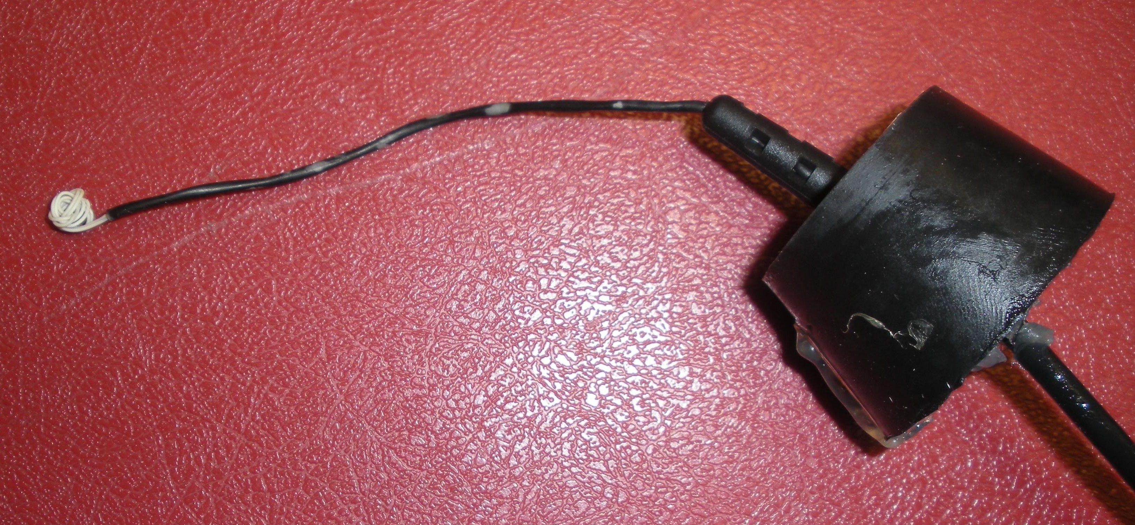 | 1. Spread slit in stopper and thread thermistor wire through.  2. Ball up thermistor from surface temperature sensor in the white wire directly above it.  - Place stopper with thermistor into flask, pushing thermistor into chipped ice so that it is enclosed.  - Seal the cut slit and top of hole with heat resistant sealant (silicone sealant recommended) to prevent steam leaks.  - Leave in freezer to cool below 0 C.

Lab Procedure

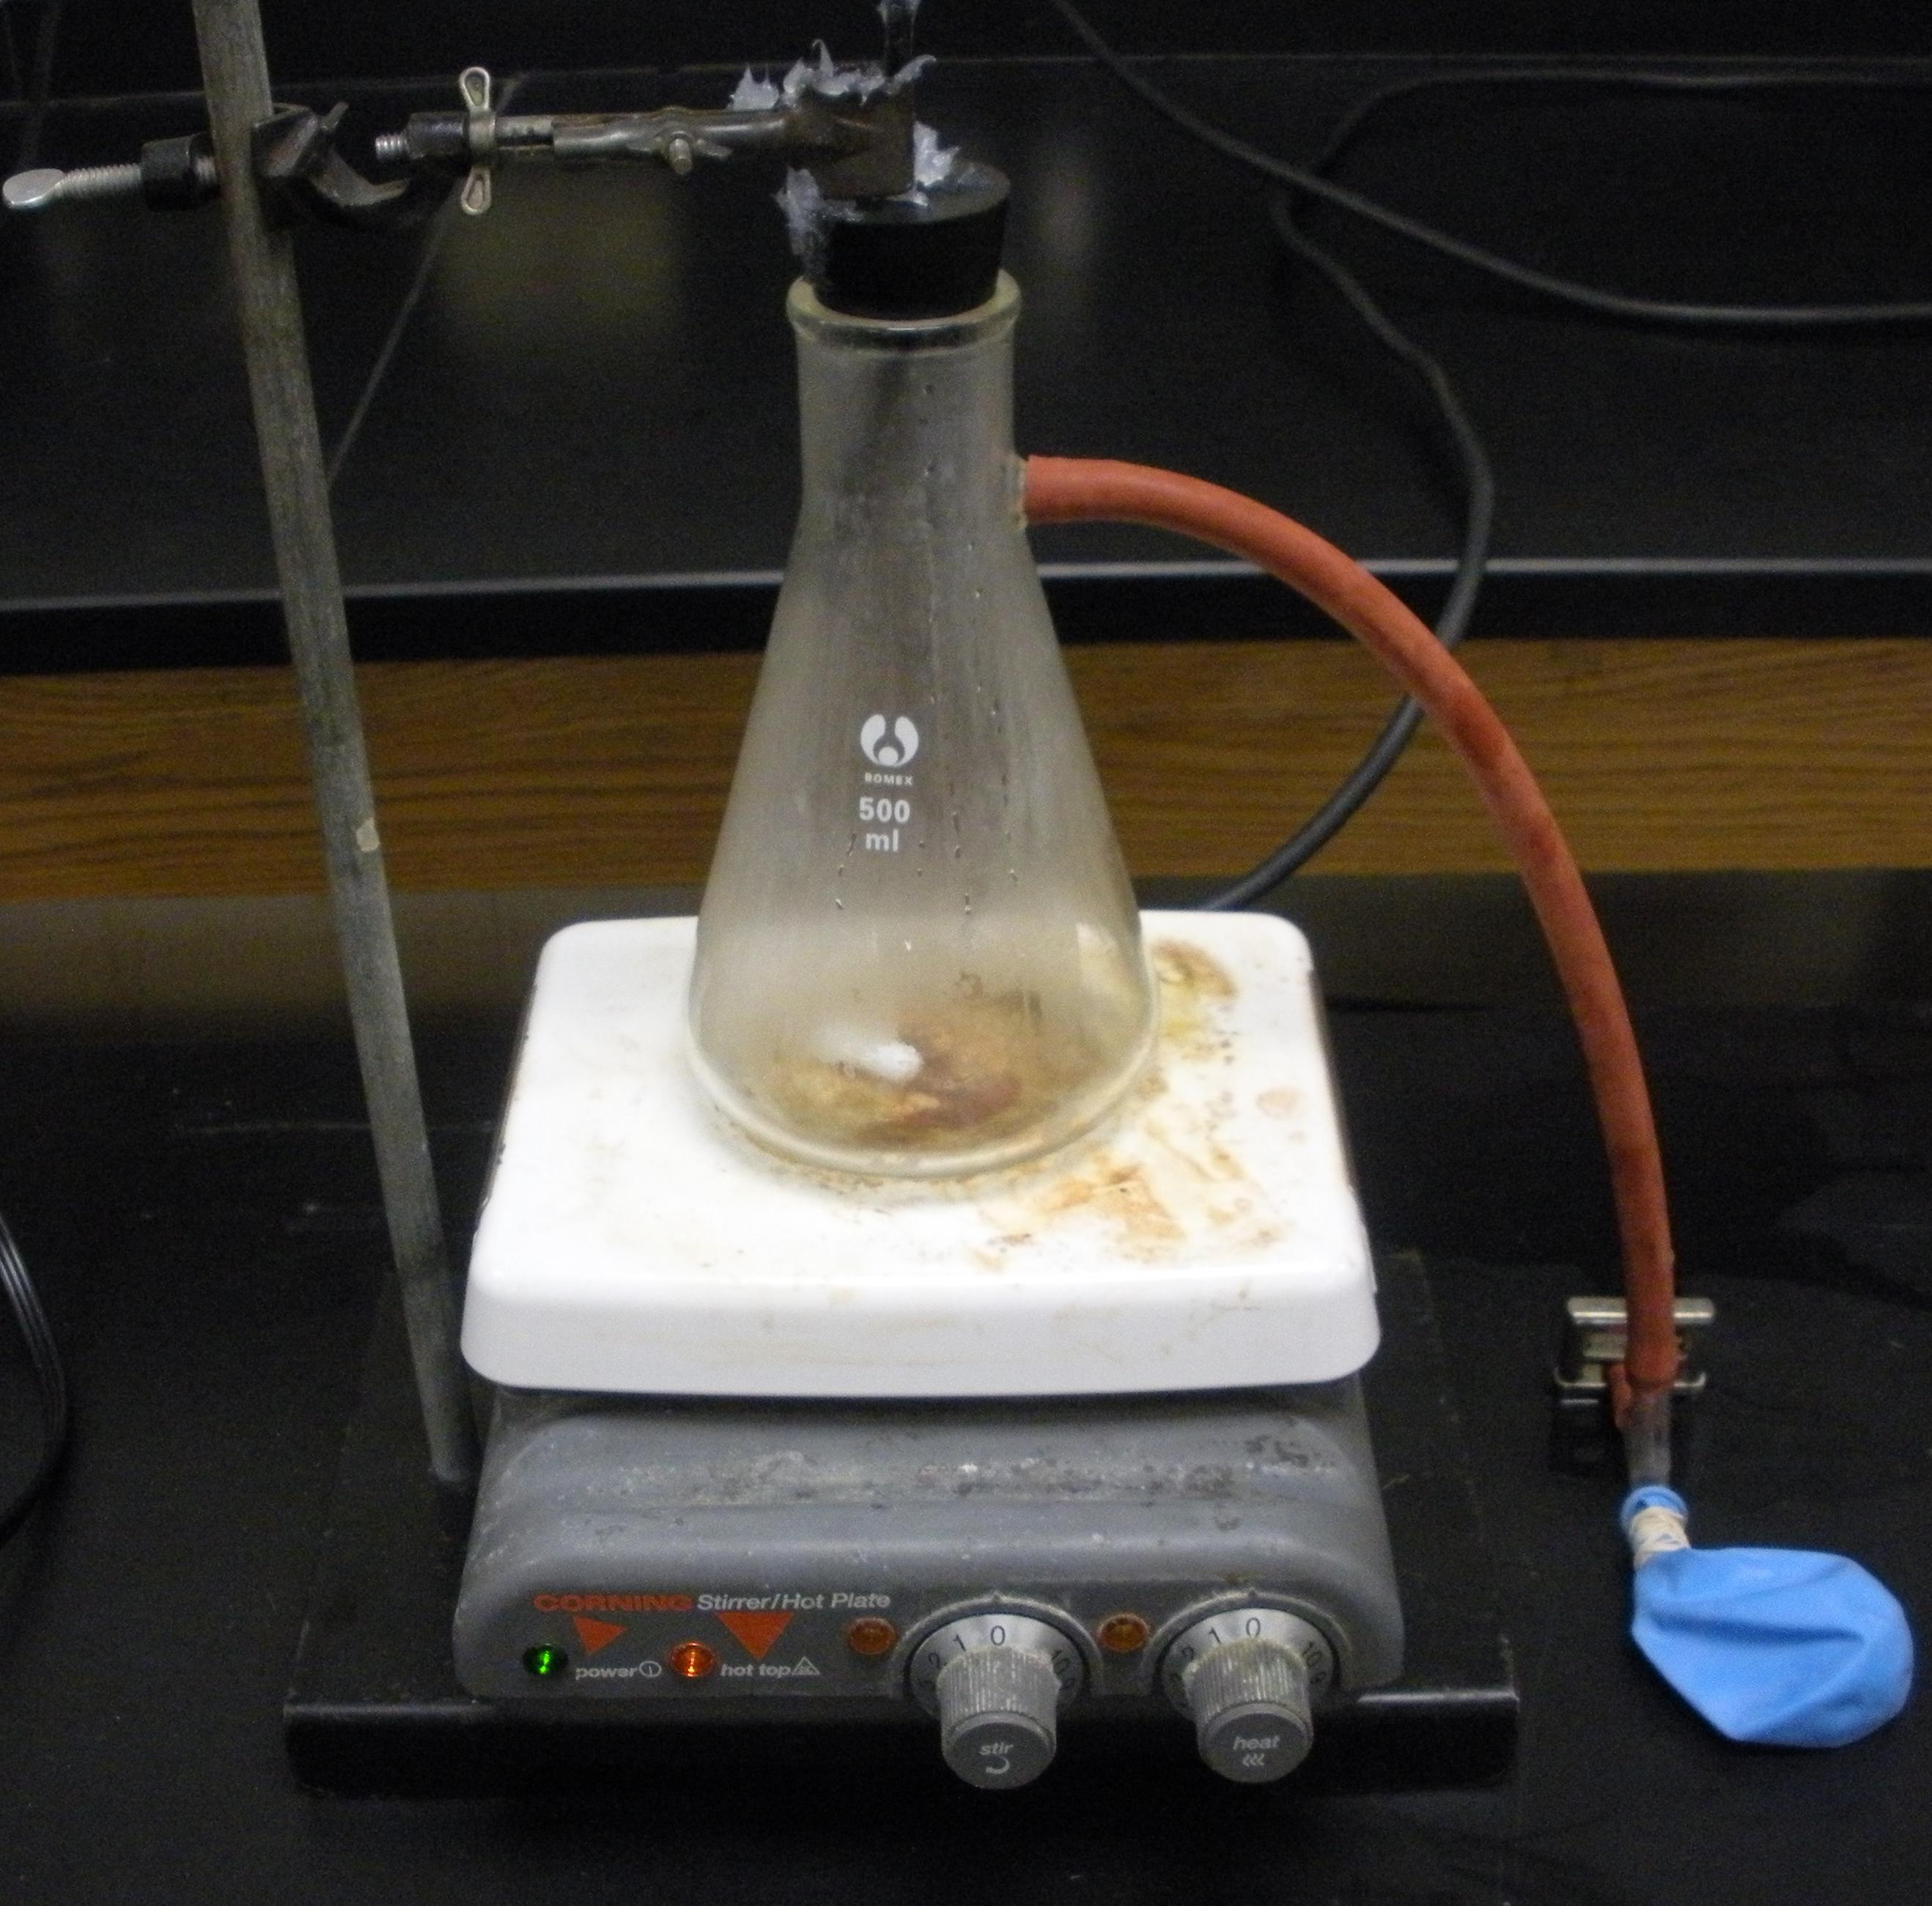
1. Weigh the entire apparatus
2. Place back in freezer to keep cool while hot plate is set up.
3. Place hot plate on table.
4. Set ring stand next to hot plate with ring stand flask clamp on it.
5. Turn hot plate to 30% power level for both heating and stirring and let it warm up.
6. Once warm, bring apparatus out from freezer.
7. Plug thermistor into LoggerPro.
8. Connect flask to rubber tubing apparatus (make sure valve is open).
9. Place apparatus on top of hot plate and begin data capture.
10. Adjust stirrer as necessary.
11. When ice has completely melted, turn hot plate to 80%.
12. When water begins to boil (100 C) turn heating plate to 100% power.
13. When approximately one milliliter of water is left, close valve, completely shutting off rubber tubing.
14. When steam temperature reaches 120 C, turn off heat pad and immediately remove apparatus from heat pad and place on heat resistant surface.
15. End data capture.

Analysis
1. Why did the temperature level off during the fusion and vaporization stages of the heating curve?
2. Why was it necessary to increase the power level of the hot plate as the temperature increased?
3. Why is the stirrer essential to this experiment?
5. What function did the balloon serve in this experiment?
4. Did your graph model those in your textbook? If not, explain possible sources of error.
5. Using the latent heat of fusion of water (3.34x10⁵ J/kg) and the collected data, find the specific heat capacity of water.

